GIT ASSIGNMENT GROUP 4

* Create and collaborate on a new empty repository on GitHub.
* Each member should make one commit each.
* This group needs to learn and discuss on the following topic - checkout
* You need to push the slides or the doc you create to this repository.
* Share it with the other class members.

By

Gaurav Gupta

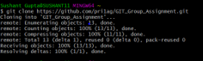

* First Cloning the remote repository into our local directory using $ git clone “repo http”

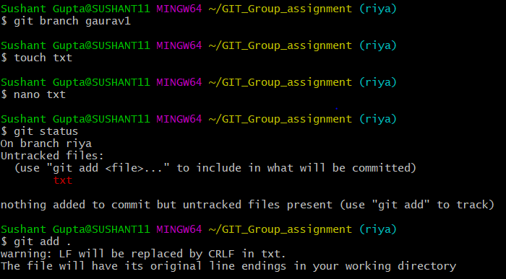

* Then making a new branch under repository using
* $ git branch “branch-name”
* Then making txt file using $ touch command and adding text to it .
* Then using git add command to add the file in the working directory

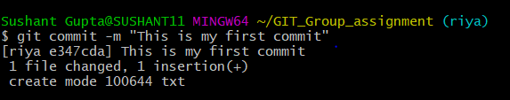

* Using git commit command I am committing that file and I have given a message for that commit to.

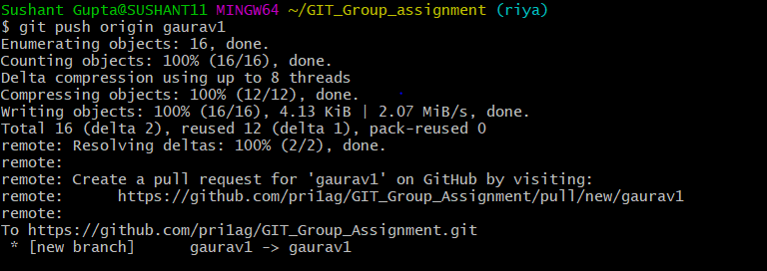

* Now I am pushing my local repo into the remote repo using command

$ git push origin “branch-name”

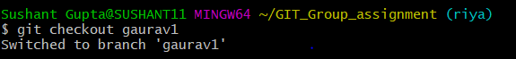

* I was working on riya branch but if I want to swtich my branch to gaurav1 then I use the command

$ git checkout gaurav1



* It undo changes you’ve made to a file in your working directory. This will revert the file back

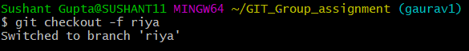

* Git -force/-f option with checkout command to force git to switch branches , even if you have un-staged changes.